User Manual

Once you have ran the deployment scripts into the database, there should be two users that you can use:

1. Username : Admin , Password: Admin, Role : Admin
2. Username: Standard, Password: Standard, Role: Standard

Please take note that only “Admin” role able to create users.

# How to login

1. Once the “SampleHost” project has ran within Visual Studio. A web browser should pop up a tab stating <http://localhost:62749/> .   
   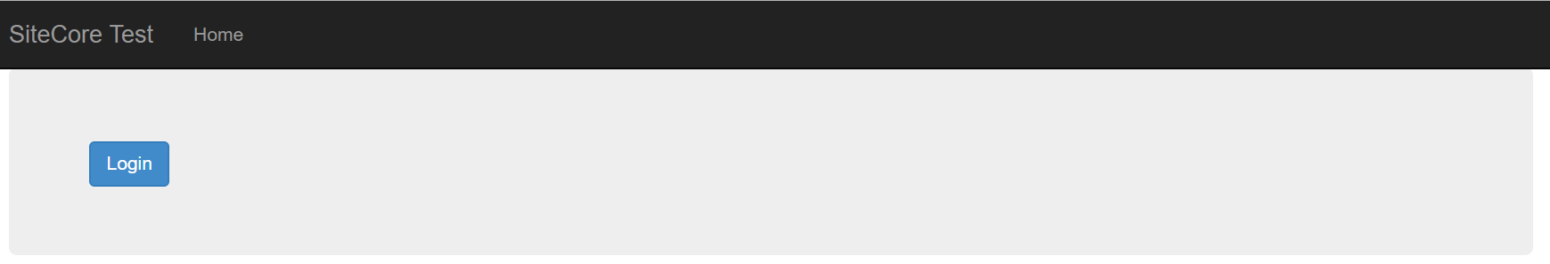
2. Click on the “Login” button. You will be redirect to login screen  
   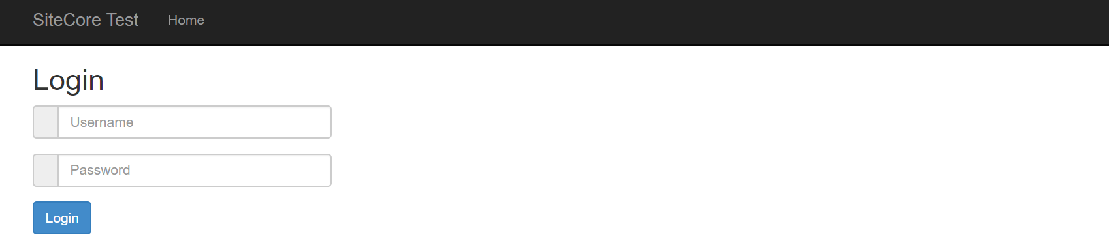
3. Key in Username = Admin, and Password = Admin, and click on “Login” button. If your authentication success, it will redirect to Admin Landing Page. If it fails the authentication, it will display a simple error message above the login button.
4. Below are a sample of Admin landing page.

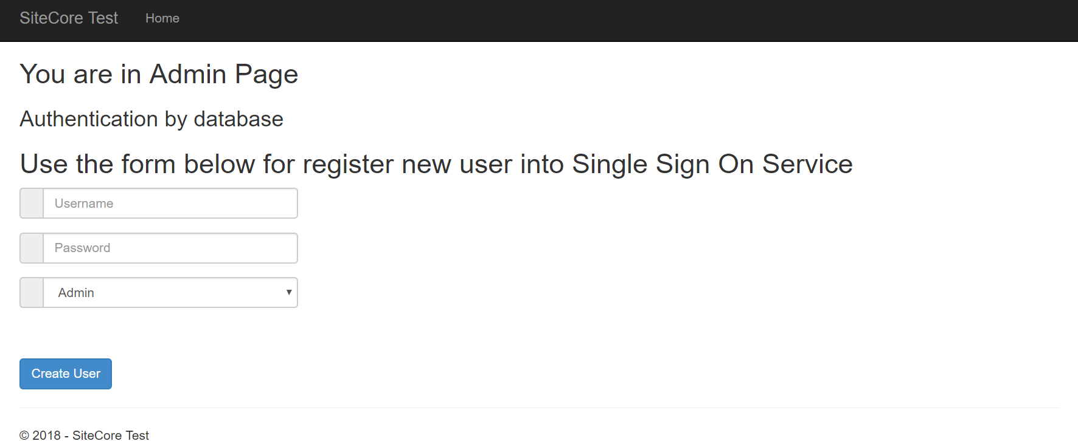

# How to create user

Once you have login using “Admin” role user account, you will be able to create user

1. Once you login using admin account, you can use the “Create User” form on admin landing page to create user. Below is the admin landing page.



1. Key in your desire username, password and role. The system does check for duplicate username. If the system found duplicate username, it will display a simple error message above the “Create User” button.